**Question Bank For Python Programming Language**

1. **Write a program to print Floyd’s Triangle.**

**Output:**

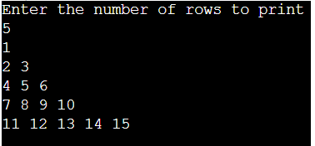

1. **Write a python program to find the GCD of two numbers.**

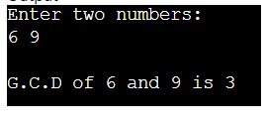

1. **Write a program to print the Fibonacci series.**
2. **Write a program to maintain names and cell numbers of 4 persons and then print them systematically in a tabular form.**

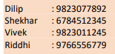

1. **Write a program to print out all Armstrong numbers between 1 and 500. If sum of cubes of each digit of the number is equal to the number itself, then the number is called an Armstrong number. For example, 153 = ( 1 * 1 * 1 ) + ( 5 * 5 * 5 ) + ( 3 * 3 * 3 ).**
2. **Write a Python program to convert two lists into a dictionary in a way that item from list1 is the key and item from list2 is the values.**
3. **Write a program to find all occurrences of 'T' in the string**

**'The Terrible Tiger Tore The Towel'.**

**Replace all occurrences of 'T' with 't'. (let us python – pg no 51)**

1. **Write a Python program to create a dictionary storing shopping items in cart with details such as  ‐ (item name: cost of item) and perform the following operations**
2. Add a new item
3. Display item value greater than 100
4. Remove the details of the specific item
5. Removes the last item details from cart.
6. **Perform the following operations on a list of numbers. –**
7. Create a list of 5 odd numbers
8. Create a list of 5 even numbers
9. Combine the two lists
10. Add prime numbers 11, 17, 29 at the beginning of the combined list
11. Report how many elements are present in the list
12. Replace last 3 numbers in the list with 100, 200, 300
13. Reverse the list.
14. Delete the list
15. **Write a Python function to  create user module to receive five integers from keyboard and get their sum and product calculated. (let us Python pp164**
16. **A list contains tuples containing roll number, names and age of student. Write a Python program to gather all the names from this list into another list. (let us python – pg117)**
17. **Write a necessary program to build a database connectivity for simple student and Mini Project management System using Python.**
18. Accept [Mini project name, Team members, Technologies used, Mini Project completion deadline]
19. Display ‐ displays the details of every Project
20. Search ‐ Look for a specific student and the project on which he or she is working
21. Delete ‐ delete a particular record (based on either project/employee
22. Update ‐ Update the team members for a particular mini project"
23. **Write a program to build a simple Employee and Project management System using Python functions which can perform the following operations:**
24. Accept [Project name, Team members, Technologies used, Project completion deadline]
25. Display ‐ displays the details of every Project
26. Search ‐ Look for a specific employee and the project on which he or she is working
27. Delete ‐ delete a particular record (based on either project/employee
28. Update ‐ Update the team members for a particular project"
29. **Write a python program to demonstrate different functions of OS module in python.** (let us python – pg no 336)
30. **Write a program to read the contents of file ‘message’ one character at a time. Print each character that is read.**(let us python – pg no 337)
31. **Write a Python program that accepts a list of integers and checks the length and the third element. Return true if the length of the list is more than 10 and the third element occurs twice in the said list. And also Sort the list in ascending order.**

**17) Write a generic program to handle exception generated in following scenarios:**

1. Division by Zero
2. Accessing a file which does not exist.
3. Addition of two incompatible types
4. Trying to access a nonexistent index of a sequence"

**18)Write a program that infinitely receives positive integer as input and prints its square. If a negative number is entered then raise an exception, display a relevant error message and make a graceful exit. .**(let us python – pg no 309)

**19)Write a Python program that reports the time of creation, time of last access and time of last modification for a given file. (let us python – pg no 330)**

**20)Write a program that receives an integer as input. If a string is entered instead of an integer, then report an error and give another chance to user to enter an integer. Continue this process till correct input is supplied. (let us python – pg no 314)**